Indirect vaccine effectiveness of TCV
Indirect protection conferred by the Vi‑TT typhoid conjugate vaccine has been assessed in a large cluster‑randomised trial in Dhaka, Bangladesh. Conventional analysis and a subsequent “fried‑egg” re‑analysis both found modest, non‑significant IVE of 17–19% despite high total VE (85%) and overall VE (57%) in the same study (1,2).

For the primary modelling scenario we therefore used IVE = 17%. To test the impact of more optimistic assumptions, we explored a bor

conducted a sensitivity analysis with IVE = 50%. This upper bound is informed by (i) the algebraic relationship, which yields ≈50 % at the trial’s overall population coverage (f ≈ 0.20), and (ii) the 44 % indirect protection observed for the Vi‑polysaccharide vaccine in Kolkata (3,4).

IVE = (OVE -f*TVE)/(1-f), where

OVE: overall vaccine effectiveness
TVE: total vaccine effectiveness
IVE: indirect vaccine effectiveness
f: vaccine coverage

Paper | Population size | Total vaccinated | Vaccine coverage (%) | Overall VE (%) | Total VE (%) | Indirect VE (%) | Ref
Ali 2020 (Vi-polysaccharide) | 31075 | 18869 | 61% | 57 (37-71) | 61 (41-75) | 44 (2-69) | (3)
Khanam 2023 (Vi-TT) | 155841 | 30882 | 20% | 57 (44-66) | 85 (76-90) | 17 (-13-40) | (1)

The Dhaka trial vaccinated 61 756 children among 311 289 residents, giving ≈20 % population coverage. The theoretical IVE at this coverage (≈50 %) exceeds the observed value, highlighting the limitations of the mass‑action assumption in real‑world settings with age‑restricted vaccination, substantial migration, and mixed environmental and person‑to‑person transmission. Further field studies that include adults or achieve ≥60 % population‑wide coverage are needed to quantify the true potential for Vi‑TT herd effects.

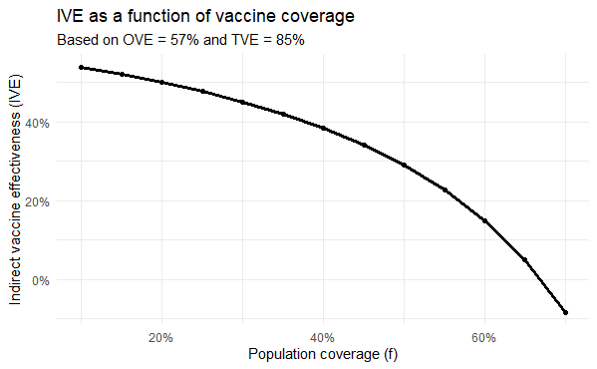

1. Khanam F, Kim DR, Liu X, Voysey M, Pitzer VE, Zaman K, et al. Assessment of vaccine herd protection in a cluster-randomised trial of Vi conjugate vaccine against typhoid fever: results of further analysis. eClinicalMedicine [Internet]. 2023 Apr 1 [cited 2025 Jul 23];58. Available from: https://www.thelancet.com/journals/eclinm/article/PIIS2589-5370(23)00102-5/fulltext
2. Qadri F, Khanam F, Liu X, Theiss-Nyland K, Biswas PK, Bhuiyan AI, et al. Protection by vaccination of children against typhoid fever with a Vi-tetanus toxoid conjugate vaccine in urban Bangladesh: a cluster-randomised trial. The Lancet. 2021 Aug 21;398(10301):675–84.
3. Ali M, Sur D, Kanungo S, Qadri F, Kim DR, Islam T, et al. Re-evaluating herd protection by Vi typhoid vaccine in a cluster randomized trial. International Health. 2020 Jan 1;12(1):36–42.

